**kashpi.com**

**Software Requirements Specification**

**\*or**

Screening

Technical Design Document

Table of Contents

1. Introduction 2

1.1 Purpose 2

1.2 Scope 2

1.3 Document Organization 2

2. General Description 3

1.1 Web Site Appearance 3

3. External Interface Requirements 3

3.1 Home page

3.2 Products

3.3 Terms of Delivery

3.4 Contacts

4. FUNCTIONAL REQUIREMENTS 4

5. USE CASES 4

6. NON-FUNCTIONAL REQUIREMENTS 4

Introduction

* 1. Purpose

The purpose of this document is to outline the technical design of the online flowerpots trading and provide an overview for the web trading implementation.

* 1. Scope

This document identifies the tools, technologies and design patterns to be used web trading kaspi.com. The Web Site Design outlined in this document builds upon the scope defined in the Requirements phase.

## 1.3 Document Organization

General Description

## 1.1 Web Site Appearance



Terms of Delivery

Contacts

Products

Home Page

* **Home Page -** provides short description about the company.
* **Products -** gives customer access to all the products.
* **Terms of Delivery -** describe all the conditions about the delivery.
* **Contacts -** provides to the costumer information for contact to the seller.

## Product perspective

Kashpi.com will be an e-commerce website. End user must only need a conventional web browser in order to use the website. The interface should be easy to use and order products. The website will be visualized in one language only – Bulgarian. Software provider must implement options for turning the website multilingual in the future. For that reason we require translation field when pages are added in the website administration panel.

Table

## Product functions

## User characteristics

## General constraints

## Assumptions and dependences

External Interface Requirements

**The web site should :**

* sub menu with quick links for product categories
  + Links should be clear and indicated, when user hovers over them.
* provide a information about the company.
* gives to the costumer information about current promotions.
* allows the customers to choose from the entire range of products
* provides all the products in various categories for costumer convenience.
* provides a shopping cart tool for costumers convenience.
* gives full terms of delivery to the costumer.
* gives a contact information with the seller.

**3.1** **Home page –** at the home page the customer should find a information about the company and its activities, current offers and newest products.

**3.2** **Products :**

* Catalog - containing all products.
* Flowerpots - containing flowerpots type products.
* Pots with irrigation system - containing product pots with irrigation system.
* Pots with lights - contain pots with lights products.
* Other pots - containing other type of pots.
* Accessory - containing accessory products for pots.

**3.3** **Terms of Delivery -** the costumer should find all the steps and conditions for the delivery so the costumer and the seller be satisfied.

**3.4** **Contacts -** contains the address of the company, phone, email, work time, and a map for the costumer convenience.

3.5 All pages - Counter below the site, showing the amount of entries in website. This counter should be present on every page.

3.6 All pages - Right column with shopping cart and last products to be present on every page and to link to the appropriate product page.

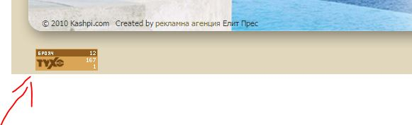

counter

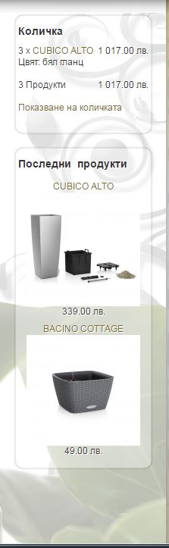

Right column - to be present on every page of the site

Functional Requirements

**Provides effective product choice:** gives to the customer opportunity easy to choice any product. The products are shown by name and image. The site keeps information about previous viewed products to facilitate the customer with the choosing.

**Click on product:** after a choosing product the customer can easy open and get full information about it only by one click. The customer can see all possible colors and sizes of the product. It can see full size image by click on the small image. Provides detailed information about the price ordered by the product size.

**Choosing product details:** the customer can choose from desired product details (color and size) and can order desired quantity. The site provides an opportunity to go to shopping cart tool and execute the order or leave the chosen product in shopping cart tool and continue shopping.

**Shopping cart:** provide to the customer information about the order (product name, price, quantity). Gives the opportunity to change or remove products.

Product

Catalog

Home Page

Shopping cart

Flowerpots

Products

Pots with irrigation system

Send Order

Terms of Delivery

Pots with lights

Contacts

Other pots

Accessory

# USE CASES

# NON-FUNCTIONAL REQUIREMENTS

* All pages to be accessible from the Homepage
* All pages should be accessible on modern browsers (Chrome, Firefox, IE9+, Safari, Vivaldi), as wel as on touch devices (tablets and mobile phones). Site should be tested on mobile OSs - Android, iOS and Windows Mobile.
* Site should be optimized for fast loading times